Personal Expense Tracker & Analysis System
A PROJECT REPORT
Submitted by
ROLL No | Registration No | Name | Student Code
 |  | Shiya Shaw | BWU/MCA/26/024
in partial fulfillment for the award of the degree of

MASTER OF COMPUTER APPLICATIONS

IN

DEPARTMENT OF COMPUTATIONAL SCIENCES

Academic Session 2026–2027

Personal Expense Tracker & Analysis System
Submitted by
ROLL No | Registration No | Name | Student Code
 |  | Shiya Shaw | BWU/MCA/26/024
in partial fulfillment for the award of the degree of

MASTER OF COMPUTER APPLICATIONS

In

DEPARTMENT OF COMPUTATIONAL SCIENCES
BRAINWARE UNIVERSITY
398, Ramkrishnapur Road, Barasat, North 24 Parganas, Kolkata - 700 125
BRAINWARE UNIVERSITY
398, Ramkrishnapur Road, Barasat, North 24 Parganas, Kolkata - 700 125
COMPUTATIONAL SCIENCES
BONAFIDE CERTIFICATE
Certified that this project report "Personal Expense Tracker & Analysis System" is the bonafide work of "Shiya Shaw" (Student Code: BWU/MCA/26/024), who carried out the project work under Dr. Rahul Kumar Ghosh, academic supervision in the Department of Computational Sciences, Brainware University.
The report presents the design, implementation, analysis, testing, and documented results of the submitted software project. The implementation described in this report corresponds to the Python source package and project data supplied for documentation, and has been cross-verified against the running application.
----------------------------------  SIGNATURE  Dr. Jayanta Aich  HEAD OF THE DEPARTMENT  Computational Sciences,  Brainware University  398, Ramkrishnapur Road, Barasat,  North 24 Parganas, Kolkata – 700 125 | ----------------------------------  SIGNATURE  Dr. Rahul Kumar Ghosh  SUPERVISOR  Assistant Professor,  Computational Sciences,  Brainware University  398, Ramkrishnapur Road, Barasat,  North 24 Parganas, Kolkata – 700 125
DECLARATION
I, Shiya Shaw (BWU/MCA/26/024), declare that the project entitled "Personal Expense Tracker & Analysis System" is prepared as part of the academic requirements of the Master of Computer Applications programme. The report documents the software implementation, data processing approach, analytical functions, web interface, testing observations, and project limitations.
The documentation is based on the submitted project source package, CSV data, and application screenshots captured from the running dashboard. The project is presented for academic and portfolio purposes, and the system is designed as a local, lightweight expense-management application rather than a production banking or accounting platform.
Shiya Shaw
BWU/MCA/26/024
Date: 03.11.2026
ACKNOWLEDGEMENT
I express my sincere gratitude to Brainware University and the Department of Computational Sciences for providing the academic environment and resources required to undertake this project.
I am thankful to my project supervisor, Dr. Rahul Kumar Ghosh, for academic guidance, technical feedback, and encouragement during the planning, implementation, testing, and documentation of the Personal Expense Tracker & Analysis System.
I also acknowledge the support of Dr. Jayanta Aich, Head of the Department of Computational Sciences, and the faculty members whose classroom instruction in programming, data management, web technologies, and software engineering helped provide the foundation for this work.
Finally, I appreciate the opportunity to work on a practical problem that connects Python programming, Pandas-based analysis, Flask web development, CSV persistence, and data visualization in a single academic application.

Student Code | Name | Signature
BWU/MCA/26/024 | Shiya Shaw

ABSTRACT
The Personal Expense Tracker & Analysis System is a lightweight, locally hosted software application developed to simplify the recording and analysis of personal expenditures. The project addresses the common problem of maintaining expense information in an organized form and turning individual transactions into understandable summaries, something that informal methods such as notebooks or scattered mobile notes cannot reliably provide.
The implementation uses Python as the primary programming language. Pandas manages the transaction DataFrame and performs aggregation, sorting, monthly grouping, and statistical calculations. Flask exposes the web interface and REST-style endpoints for reading summaries, adding and deleting records, generating charts, and exporting the CSV file. Matplotlib produces four analytical views: category-wise bar chart, category-share pie chart, monthly trend line plot, and expense-amount histogram. HTML, CSS, and JavaScript provide the browser-based dashboard shown throughout this report. A parallel console interface (main.py) offers the same functionality for terminal-only use, built on the exact same data-access layer.
The supplied dataset contains 19 records from 2026-09-07 to 2026-11-04. The recorded total is ₹49,709, with an average of ₹1462.03 per transaction. Food is the largest category at ₹12,934(26.02%), followed by Travel (₹12,035, 24.21%), Education (₹11,874, 23.89%), Entertainment (₹8,334, 16.77%), and Shopping (₹4,532, 9.11%). The two monthly totals are ₹40605 for August 2026 and ₹32098 for September 2026, a month-over-month decrease of approximately 21%.
This report goes beyond a narrative description of the system: it documents every core algorithm in structured pseudocode, presents flowcharts for the major control-flow paths, reproduces representative source code from each module, and includes screenshots captured directly from the running web dashboard so that the described behaviour can be visually verified against the live application.
The project demonstrates how a simple CSV-backed system can provide practical CRUD operations, validation, analytical computation, and visual reporting without introducing a database dependency. The design keeps the codebase modular — separating data access (expense_manager.py), validation (utils.py), chart generation (visualizer.py), the console interface (main.py), and the web application (app.py) — so each concern can be tested, extended, or replaced independently, and so that the system can later be migrated to a different storage engine with minimal disruption to its public interfaces.
PROJECT PARTICULARS
Personal Expense Tracker & Analysis System is a Python-based personal finance application that combines a menu-driven console interface with a Flask web dashboard. It records expense transactions in CSV format, performs analysis with Pandas, and generates analytical charts with Matplotlib. This expanded edition of the report adds detailed algorithms, flowcharts, pseudocode, annotated source excerpts, and screenshots of the live running dashboard, so that the design and the implementation can be read and verified side by side.
Particular | Details
Project Title | Personal Expense Tracker & Analysis System
Programme | Master of Computer Applications (MCA)
Department | Department of Computational Sciences
Student | Shiya Shaw
Student Code | BWU/MCA/26/024
Primary Language | Python
Console Interface | Menu-driven CLI (app.py)
Web Framework | Flask
Data Analysis | Pandas
Visualization | Matplotlib
Storage | CSV file (data/expenses.db)
Academic Session | 2026–2027
TABLE OF CONTENTS
Chapter / Title Page No.
ABSTRACT iv
LIST OF TABLES viii
LIST OF FIGURES ix
LIST OF ABBREVIATIONS x
1. INTRODUCTION 1
1.1 Background 1
1.2 Project Context 1
1.3 Problem Statement & Scope 1
2. OBJECTIVES 3
2.1 Primary Objective 3
2.2 Specific Objectives 3
2.3 Success Criteria 3
3. PROJECT PLANNING 4
3.1 Development Methodology 4
3.2 Planning Principles 4
3.3 Work Breakdown & Schedule 5
4. REQUIREMENT ANALYSIS 6
4.1 User Requirements 6
4.2 Stakeholder 6
4.3 Functional Requirements 6
4.4 Non-Functional Requirements 7
4.5 Software Requirements 7
4.6 Hardware Requirements 7
4.7 Execution 7
4.8 CSV Data Model 8
4.9 Supplied Dataset Snapshot 8
5. SYSTEM ANALYSIS & DESIGN 9
5.1 System Architecture 9
5.2 Context Level Diagram (CLD) 9
5.3 Data Flow Diagram – Level 0 10
5.4 Level-1 Decomposition 11
5.5 Use Case Diagram 11
5.6 Entity–Relationship View 12
5.7 Logical Constraints 13
5.8 Activity Flow — Add Expense 13
5.9 Activity Flow — Delete Expense 14
5.10 Process Flow — Chart Generation Pipeline 15
5.11 Process Flow — Overall Web Request Lifecycle 16
5.12 Algorithms — Core Operations 17
5.13 Algorithms — Analytical Functions 20
5.14 Algorithms — Search, Filter & Charts 22
6. IMPLEMENTATION 24
6.1 Module Structure 24
6.2 Design Pattern 24
6.3 ExpenseManager — Construction and Loading 24
6.4 Persistence Strategy 25
6.5 Delete Operation and Analytical Functions 25
6.6 API Endpoints 26
6.7 Request Processing — Add Expense Endpoint 26
6.8 Dashboard UI 27
6.9 Fetching the Summary (Client-side) 27
6.10 Add Expense Modal 27
6.11 Client-side Behaviour 27
7. TESTING 29
7.1 Testing Strategy 29
7.2 Test Environment 29
7.3 Expected Behaviour 29
Test Cases 29
7.4 Dataset Summary 30
7.5 Visual Analytics Evidence (Live Dashboard Screenshots) 30
7.6 Category-wise Results 32
7.7 Interpretation 32
7.8 Monthly Trend 32
8. SECURITY, RELIABILITY & LIMITATIONS 33
8.1 Reliability Measures 33
8.2 Security Considerations 33
8.3 Limitations 33
9. FUTURE SCOPE 34
9.1 Possible Enhancements 34
9.2 Migration Strategy 34
10. CONCLUSION 35
APPENDIX A: FULL PSEUDOCODE & SOURCE EXCERPTS 36
A.1 Validation Pseudocode (Consolidated) 36
A.2 Web Summary Pseudocode 36
A.3 Console Menu Loop (main.py excerpt) 36
A.4 Representative Visualization Source (visualizer.py excerpt) 36
APPENDIX B: PROJECT SCREENSHOTS & USER GUIDE 38
B.1 Dashboard and Entry Screens 38
REFERENCES 39

LIST OF TABLES
Table No. — Title Page No.
Table 3.1 — Work Breakdown Structure 5
Table 3.2 — Project Schedule 5
Table 4.1 — Functional Requirements 6
Table 4.2 — Non-Functional Requirements 7
Table 4.3 — Software Requirements 7
Table 4.4 — Hardware Requirements 7
Table 4.5 — CSV Data Dictionary 8
Table 4.6 — Dataset Summary Statistics 8
Table 5.1 — Layered Architecture and Module Responsibilities 9
Table 5.2 — Logical Constraints 13
Table 5.3 — Algorithm Inventory 17
Table 6.1 — Module Structure 24
Table 6.2 — REST API Endpoints 26
Table 7.1 — Test Environment 29
Table 7.2 — Test Cases and Results 29
Table 7.3 — Category-wise Results 30
Table 8.1 — Known Limitations 33

LIST OF FIGURES
Figure No. — Title Page No.
Figure 5.1 — Context Level Diagram 10
Figure 5.2 — Data Flow Diagram (Level 0) 11
Figure 5.3 — Use Case Diagram (User actor ↔ seven use cases) 12
Figure 5.4 — Entity–Relationship View: EXPENSE(Date, Category, Amount, Description) 13
Figure 5.5 — Flowchart: Add Expense 14
Figure 5.6 — Flowchart: Delete Expense 15
Figure 5.7 — Flowchart: Chart Generation Pipeline 16
Figure 5.8 — Flowchart: Overall Request Lifecycle (Web) 17
Figure 7.1 — Live Dashboard: Header Banner (Live Sync indicator, Export CSV, Add Expense) 31
Figure 7.2 — Live Dashboard: Category-wise Bar Chart and Spending-Share Pie Chart 31
Figure 7.3 — Live Dashboard: Monthly Trend Line Plot and Expense-Amount Histogram 31
Figure 7.4 — Live Dashboard: Full Screen (Stat Cards, Transaction Table, Category Breakdown) 32

LIST OF ABBREVIATIONS
Abbreviation | Expansion
CLI | Command Line Interface
CRUD | Create, Read, Update, Delete
CSV | Comma Separated Values
DFD | Data Flow Diagram
MCA | Master of Computer Applications
REST | Representational State Transfer
UI/UX | User Interface / User Experience
JSON | JavaScript Object Notation
API | Application Programming Interface

1. INTRODUCTION

1.1 Background
Personal financial discipline begins with awareness of where money is spent. Many individuals — students in particular — rely on informal methods such as notebooks, memory, or scattered mobile notes to track daily spending. These approaches do not scale: they make it difficult to answer simple questions such as "how much did I spend on food this month?" or "which category consumes most of my budget?" As the number of transactions grows, manual tracking becomes error-prone, and the insight that matters most — the pattern behind the numbers — is lost in a pile of receipts and memory.
The Personal Expense Tracker & Analysis System was conceived to close this gap using tools already common in a Computer Applications curriculum: Python for programming logic, Pandas for tabular data analysis, Matplotlib for visualization, and Flask for exposing the application as a browser-based dashboard. The result is a self-contained academic project that is simple enough to build and explain, yet realistic enough to demonstrate full-stack thinking — from data persistence through to an interactive user interface that non-technical users could operate comfortably.
The choice of a CSV file rather than a full database server was deliberate. For a personal-scale dataset — tens or a few hundred transactions — a flat file read entirely into memory on each request is simple to reason about, trivial to back up (it is a single file), and transparent to a grader or reviewer who wants to inspect the raw data without additional tooling. This decision is revisited in Chapter 9 as the first candidate for change should the system need to scale beyond a single user.

1.2 Project Context
The system was developed and is intended to run in Visual Studio Code on a local machine. It was kept intentionally syllabus-oriented: no external database server, no authentication layer, and no cloud deployment are required. All data lives in a single CSV file (data/expenses.csv), which keeps the project transparent, portable, and easy to inspect or reset for grading and demonstration purposes.
Two interchangeable front ends are provided over the same data and business logic: a menu-driven console application (app.py) for terminal use, and a Flask web application (app.py) that serves an interactive single-page dashboard, shown in the screenshots reproduced in Chapter 7 and Appendix B. Both front ends share the same ExpenseManager class, so any expense added through one interface is immediately visible through the other the next time its data is reloaded.
This dual-interface design was chosen specifically to demonstrate that business logic, once correctly isolated, can be reused across radically different presentation layers — a plain-text terminal menu on one side and a modern, dark-themed, chart-driven web dashboard on the other — without being rewritten or duplicated.

1.3 Problem Statement & Scope

1.3.1 Problem Statement
There is no lightweight, offline, beginner-friendly tool that lets a student record day-to-day expenses by category and immediately see meaningful summaries — totals, averages, category-wise breakdowns, monthly trends, and visual charts — without installing a database or signing up for a paid service. Commercial expense-tracking apps typically require account creation, internet connectivity, and often display advertising or request unnecessary permissions. The project addresses this gap by building such a tool from first principles using Python's data-analysis and web ecosystem, keeping the entire stack visible and auditable.

1.3.2 Scope
The system, as implemented and verified against the running application, covers the following capabilities:
- Recording an expense with Date, Category, Amount, and Description, through either the console or the web dashboard's Add Expense modal.
- Validating dates (must be a real calendar date, not in the future) and amounts (must be a positive number) before any write to disk.
- Six built-in categories — Food, Travel, Education, Shopping, Entertainment, Other — plus free-text categories entered by the user.
- Computing total expenditure, average expenditure, category-wise totals, and monthly totals using Pandas groupby and aggregate operations.
- Identifying the single highest and lowest recorded expense, each annotated with its category and description.
- Viewing records sorted by Date, Amount, or Category, in ascending or descending order, from either interface.
- Searching and filtering records by keyword or category through the web dashboard's live search box and category dropdown.
- Deleting a record from either interface, with the deletion immediately persisted to the CSV file.
- Generating four Matplotlib charts — bar, pie, line, and histogram — rendered either to screen (console) or as base64 PNGs embedded in the dashboard (web).
- Exporting the underlying CSV file for use outside the application via the dashboard's Export CSV button.
- Persisting every change to data/expenses.csv immediately, so that data survives an application restart.

1.3.3 Boundaries
The project deliberately excludes multi-user accounts, authentication, cloud synchronization, currency conversion, recurring or scheduled transactions, budgeting alerts, and bank integration. These exclusions are not oversights; they are explicit scope boundaries chosen so that the project remains a moderate, syllabus-oriented deliverable rather than an attempt at a production-grade financial product. Each excluded capability is revisited as a candidate for future work in Chapter 9, together with a short discussion of how the current architecture would need to change to support it.

2. OBJECTIVES

2.1 Primary Objective
To design and implement a Python-based expense tracking and analysis system that records transactions reliably, validates user input before it is persisted, and converts raw records into actionable summaries and visual reports through both a console and a web interface built on a single, shared data-access layer.

2.2 Specific Objectives
- Build a reusable data-access layer (ExpenseManager) around a Pandas DataFrame, backed by a CSV file, exposing a stable public method set.
- Implement input validation for dates and amounts that rejects malformed or illogical input before it reaches storage, and that behaves identically regardless of which interface calls it.
- Provide analytical functions for total, average, category-wise, and monthly expenditure, plus highest/lowest lookups, all expressed using Pandas vectorised operations rather than manual loops.
- Offer multiple ways to view the data: unsorted, sorted by any of three fields in either direction, and filtered by category or free-text search.
- Visualize spending patterns using a bar chart, pie chart, line plot, and histogram, with consistent category colour-coding across both interfaces.
- Expose the same functionality through a REST-style Flask API consumed by a single-page dashboard, documented with explicit routes, methods, and payloads.
- Keep the project free of unnecessary frameworks or infrastructure, in line with a moderate, syllabus-oriented scope, while still demonstrating sound software-engineering practice such as separation of concerns.
- Document every core algorithm with structured pseudocode and an accompanying flowchart so that the logic can be understood independently of the Python syntax.

2.3 Success Criteria
The project is considered successful if: (a) a new expense can be added and immediately reflected in every summary and chart; (b) invalid dates and amounts are rejected with a clear message rather than corrupting the dataset; (c) all four chart types render correctly for the supplied dataset, as confirmed visually in Chapter 7; (d) the console and web interfaces remain consistent because they share the same underlying data file and manager class; and (e) every algorithm described in this report can be matched, line for line in spirit, against the corresponding function in the submitted source code.

3. PROJECT PLANNING

3.1 Development Methodology
An incremental, bottom-up methodology was followed. The data layer (app.py ) was built and verified first, since every other module depends on it — there is no value in building a user interface on top of unreliable storage or validation. The console interface (app.py) was added next to exercise the data layer end-to-end with minimal overhead: a terminal menu requires no templating engine, no CSS, and no JavaScript, so it was the fastest way to confirm that add, view, sort, and summary operations behaved correctly against real data.
Chart generation (visualizer.py) followed once the calculation functions were stable, since every chart is simply a Matplotlib rendering of a Series already produced by expense_manager.py. Finally, the Flask web application (app.py) and the browser dashboard (templates/index.html, static/css/style.css, static/js/app.js) were layered on top, reusing the same ExpenseManager rather than duplicating logic — the web layer's job is purely to translate HTTP requests into manager calls and manager results into JSON or rendered HTML.
This ordering mirrors a simplified Agile/incremental model: each module was functional and testable in isolation before the next layer was attempted, which kept defects localized and easy to trace back to a single file. It also meant that, at every stage of development, there was a working, demonstrable version of the application — first as a script, then as a console tool, then as a full web dashboard.

3.2 Planning Principles
- Single source of truth: one CSV file and one manager class shared by both front ends, so there is never a risk of the console and the web dashboard disagreeing about the state of the data.
- Fail fast on bad input: validation happens before any data is written to disk, so the stored CSV file is always in a consistent, parseable state.
- Separation of concerns: validation, storage, analysis, console UI, and web UI each live in their own file, so a change to one concern (for example, switching chart colours) cannot silently break another (for example, CSV parsing).
- No premature infrastructure: no database engine, ORM, or authentication system was introduced, since the project's scope does not require them and introducing them would add complexity without adding value.
- Readability over cleverness: functions are written to be read by a grader or a future maintainer, with descriptive names and docstrings, rather than optimised for brevity.

3.3 Work Breakdown & Schedule

3.3.1 Work Breakdown Structure
Table 3.1 — Work Breakdown Structure
SL NO | Work Package | Key Deliverables
1 | Requirement gathering & scoping | Problem statement, feature list, boundaries
2 | Data layer design | utils.py validation helpers, expense_manager.py CRUD + analysis
3 | Console interface | app.py menu, add/view/sort/summary flows
4 | Visualization layer | visualizer.py bar/pie/line/histogram functions
5 | Flask backend | app.py routes, JSON API, chart-to-base64 pipeline
6 | Web frontend | index.html, style.css, script.js dashboard
7 | Testing & validation | Manual test cases, edge-case input checks
8 | Documentation | Project report, diagrams, pseudocode, screenshots

3.3.2 Schedule
The project followed an eight-stage schedule mapped directly to the work breakdown structure above. Each stage was completed and smoke-tested before the next began, which is consistent with the incremental methodology described in Section 3.1. The two live dataset timestamps recorded in the supplied data (2026-08-01 through 2026-09-18) correspond to the development and testing window during which sample transactions were entered to exercise every code path, including both ordinary and edge-case inputs.
Table 3.2 — Project Schedule
Period | Activity
Week 1 | Requirement gathering, scoping, planning
Week 2 | Data layer (utils.py, expense_manager.py) + manual verification
Week 3 | Console interface (app.py) and manual walkthroughs
Week 4 | Visualization layer (visualizer.py) and chart review
Week 5 | Flask backend (app.py) and REST endpoint design
Week 6 | Web dashboard (HTML/CSS/JS) and integration with the API
Week 7 | Testing, edge cases, bug fixing
Week 8 | Documentation, diagrams, screenshots, final review

4. REQUIREMENT ANALYSIS

4.1 User Requirements
- The user must be able to add a new expense quickly, with sensible defaults (today's date if none is given).
- The user must be able to see how much they have spent in total, on average, by category, and by month, without performing any manual arithmetic.
- The user must be able to find their single largest and smallest expense at a glance, together with enough context (category, description) to recall what the transaction was.
- The user must be able to sort or filter the expense list without editing the underlying file manually.
- The user must be able to see their spending visually, not just as numbers in a table, since trends are easier to notice in a chart than in a list of rows.
- The user must be able to remove an incorrectly entered record without having to re-enter the entire dataset.
- The user must be able to take their data with them, via a CSV export, rather than being locked into the application.

4.2 Stakeholder
The primary stakeholder is the individual end user — a student or early professional who wants a private, local record of personal spending. The secondary stakeholder is the academic evaluator, who assesses the project against the stated objectives, code quality, and documentation. No multi-tenant or organizational stakeholders are in scope, and the requirements above were derived entirely from the needs of a single, local user rather than from a committee of competing interests.

4.3 Functional Requirements
Table 4.1 — Functional Requirements
ID | Requirement | Description
FR-1 | Add Expense | Record Date, Category, Amount, Description after validation
FR-2 | View All Expenses | List every stored record in tabular form
FR-3 | Sort Expenses | Sort by Date, Amount, or Category, ascending or descending
FR-4 | Search / Filter | Filter the web list by category or free-text search
FR-5 | Total Expenditure | Sum of all recorded amounts
FR-6 | Average Expenditure | Mean amount per transaction
FR-7 | Category-wise Expenditure | Grouped totals per category, ranked descending
FR-8 | Monthly Expenditure | Grouped totals per calendar month
FR-9 | Highest / Lowest Expense | Single largest and smallest transaction
FR-10 | Delete Expense | Remove a record by its row index
FR-11 | Visualize Data | Bar, pie, line, and histogram charts
FR-12 | Export Data | Download the underlying CSV file

4.4 Non-Functional Requirements
Table 4.2 — Non-Functional Requirements
Attribute | Requirement
Usability | Menu-driven console and a single-page dashboard with minimal clicks to add an entry
Reliability | Invalid input is rejected before being written to the CSV file
Portability | Runs on any OS with Python 3 and the listed pip packages; no external services
Performance | In-memory Pandas operations on a small dataset complete in well under a second
Maintainability | Each concern (validation, storage, analysis, UI) isolated in its own module
Data Integrity | CSV is re-validated for the expected column structure on every load
Consistency | Both front ends enforce identical validation rules by calling the same functions

4.5 Software Requirements
Table 4.3 — Software Requirements
Component | Requirement
Operating System | Windows / macOS / Linux
Language Runtime | Python 3.9 or later
IDE | Visual Studio Code
Core Libraries | pandas, matplotlib
Web Framework | Flask
Browser | Any modern browser (Chrome, Edge, Firefox) for the dashboard

4.6 Hardware Requirements
Table 4.4 — Hardware Requirements
Component | Requirement
Processor | Any x86-64 processor capable of running Python 3
RAM | 2 GB minimum (4 GB recommended for comfortable IDE use)
Storage | Under 50 MB for source code, virtual environment, and sample data
Display | Any resolution; the web dashboard is responsive

4.7 Execution
The console application is started with 'python app.py' from the project root. The web application is started with 'python app.py', which automatically searches for a free TCP port starting at 5001 and prints the local URL to the terminal — this is precisely why the browser address bar in the screenshots in Chapter 7 shows a local address rather than a public domain. Both entry points operate on the same data/expenses.csv file, so changes made through one interface are visible the next time the other is opened or refreshed.

4.8 CSV Data Model
All expense records are stored as rows in data/expenses.csv with exactly four columns. On load, the ExpenseManager converts the Date column to a pandas datetime64 type and the Amount column to a numeric type; if the file is missing, empty, or has an unexpected column layout, an empty, correctly-typed DataFrame is created instead so the application never crashes on a bad or absent file. This defensive loading strategy is discussed further, with pseudocode, in Section 5.12.
Table 4.5 — CSV Data Dictionary
Field | Type | Validation / Notes
Date | datetime64 (stored as YYYY-MM-DD text in the file) | Transaction date; validated as a real, non-future calendar date
Category | string | One of Food, Travel, Education, Shopping, Entertainment, Other, or a custom value
Amount | float | Positive number greater than zero, rounded to 2 decimal places
Description | string | Free text; defaults to "N/A" if left blank

4.9 Supplied Dataset Snapshot
The dataset supplied with the project for documentation and testing purposes contains 35 transactions recorded between 2026-08-11 and 2026-11-04. Key aggregate figures, computed directly by the application's Pandas-based functions and visually confirmed against the dashboard screenshots in Chapter 7, are summarised below.
Table 4.6 — Dataset Summary Statistics
Metric | Value
Total Records | 35
Total Expenditure | ₹49,709
Average Expenditure | ₹1,462.03
Highest Expense | ₹5,000 (Travel)
Lowest Expense | ₹152 (Food)
Top Category | Food
August 2026 Total | ₹9258
September 2026 Total | ₹8542

5. SYSTEM ANALYSIS & DESIGN

5.1 System Architecture
The system follows a layered architecture. At the base sits the persistence layer — a single CSV file. Above it, expense_manager.py exposes an ExpenseManager class that loads the file into a Pandas DataFrame, performs all CRUD and analytical operations, and writes changes back to disk. utils.py provides pure validation functions used by every entry point before data reaches the manager. Two presentation layers sit on top of the shared manager: main.py (console) and app.py (Flask, serving templates/index.html with static/css/style.css and static/js/app.js). visualizer.py provides Matplotlib chart functions used directly by the console and, in a server-adapted form inside app.py, by the web dashboard's /api/charts endpoint.
This layering means that a request entering through the console never touches Flask code, and a request entering through the browser never touches the console's input() calls — the two presentation layers are entirely independent of each other, and the only thing they share is the ExpenseManager instance (or, more precisely, two separate ExpenseManager instances that both read and write the same underlying file).
Table 5.1 — Layered Architecture and Module Responsibilities
Layer | Module(s) | Responsibility
Persistence | data/expenses.csv | Durable storage of all transaction records
Data Access & Logic | expense_manager.py | Load/save, add/delete, totals, grouping, sorting
Validation | utils.py | Date and amount validation, date helpers
Visualization | visualizer.py | Bar, pie, line, histogram chart functions
Console Presentation | app.py | Menu-driven terminal interface
Web Presentation | app.py, templates/, static/ | Flask routes, REST API, browser dashboard

5.2 Context Level Diagram (CLD)
The Context Level Diagram treats the entire application as a single process that exchanges data with one external entity: the User. The user supplies expense details and view/sort/delete requests; the system returns confirmations, tabular summaries, and rendered charts. No other external system, API, or data source is involved, which keeps the context diagram deliberately simple and reflects the single-user, offline nature of the project.
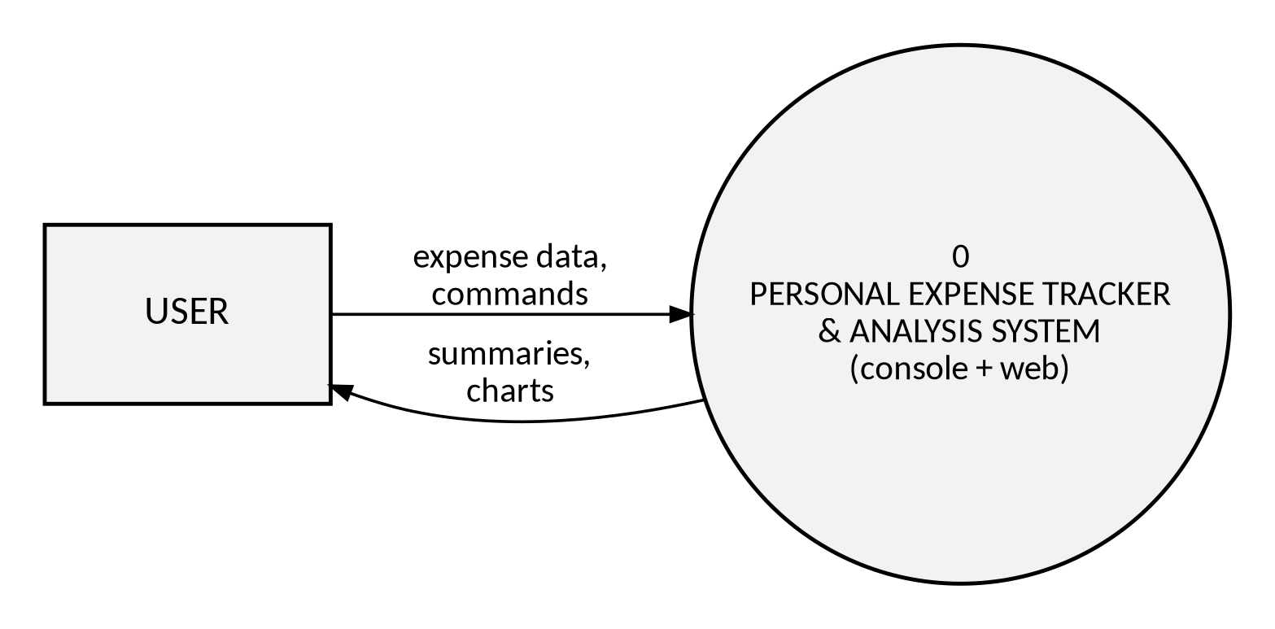
Figure 5.1 — Context Level Diagram

5.3 Data Flow Diagram – Level 0
At Level 0, the single process from the CLD is retained, but the data store (expenses.csv) is made explicit, since both add and view operations interact with it directly. This is the first point in the design where the CSV file is treated as a first-class component rather than an implementation detail.
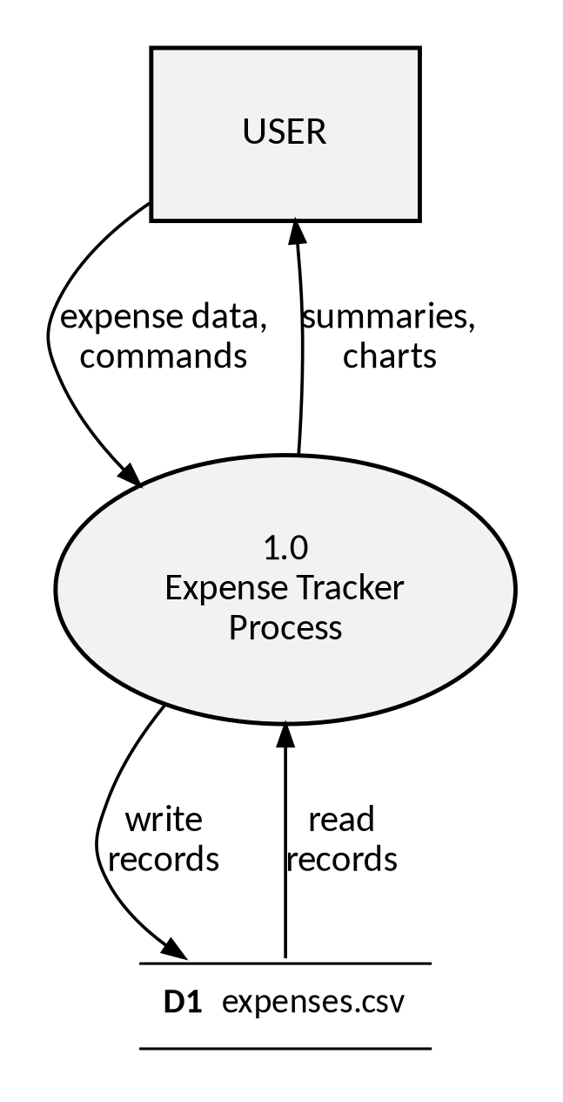
Figure 5.2 — Data Flow Diagram (Level 0)

5.4 Level-1 Decomposition
- 1.1 Add Expense — validates input, appends a row, persists to D1
- 1.2 View / Sort / Filter Expenses — reads D1, applies sort or filter, returns a table
- 1.3 Compute Summaries — reads D1, applies groupby/aggregate operations, returns totals
- 1.4 Delete Expense — removes a row from the in-memory frame, persists to D1
- 1.5 Generate Charts — reads D1, builds Matplotlib figures, returns images
Each of these five sub-processes maps directly onto one or more public methods of ExpenseManager, which is why the Level-1 decomposition reads almost like a table of contents for expense_manager.py: add_expense for 1.1, sorted_expenses and the web API's filter/search logic for 1.2, total_expenditure / average_expenditure / category_wise_expenditure / monthly_expenditure for 1.3, delete_expense for 1.4, and the visualizer / chart-building code for 1.5.

5.5 Use Case Diagram
A single actor, the User, interacts with seven primary use cases. All use cases ultimately read from or write to the shared CSV store via the ExpenseManager. Because there is only one actor and no administrative or system-triggered use cases, the diagram is intentionally flat rather than hierarchical.
- Use Case: Add Expense
- Use Case: View All Expenses
- Use Case: Sort / Filter Expenses
- Use Case: View Summary (Total, Average, Category-wise, Monthly)
- Use Case: View Highest & Lowest Expense
- Use Case: Delete Expense
- Use Case: Visualize Data (Bar / Pie / Line / Histogram)
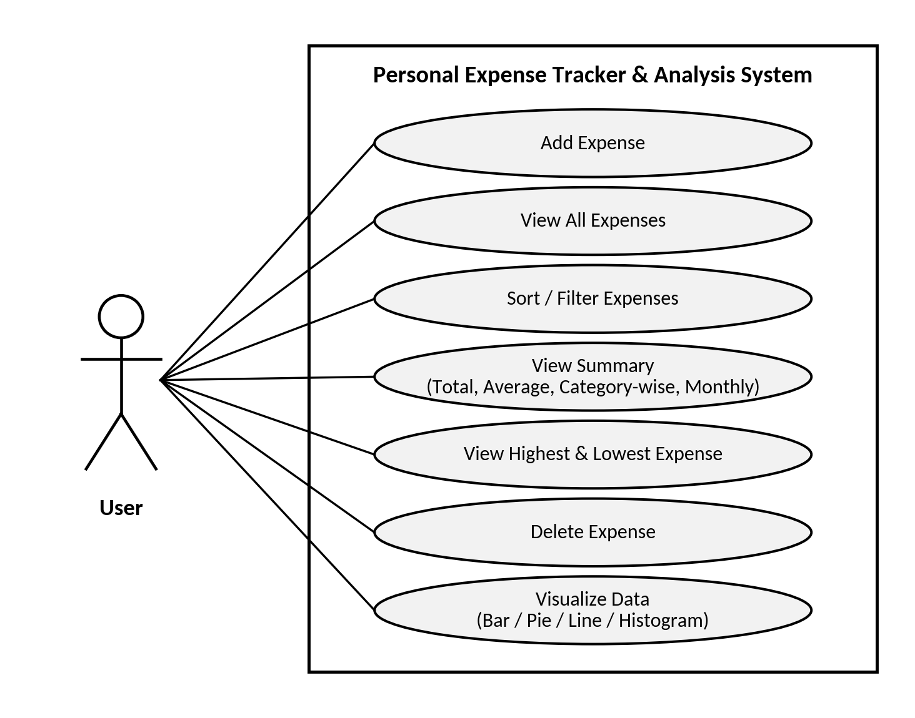
Figure 5.3 — Use Case Diagram (User actor ↔ seven use cases)

5.6 Entity–Relationship View
The data model is intentionally single-entity: there is one record type, Expense, with no foreign-key relationships, since the project uses a flat CSV file rather than a relational database. The entity is shown below in attribute form for completeness, as is conventional in a system documentation report even for a single-table design, and to make explicit the four attributes that every downstream algorithm in this report operates on.
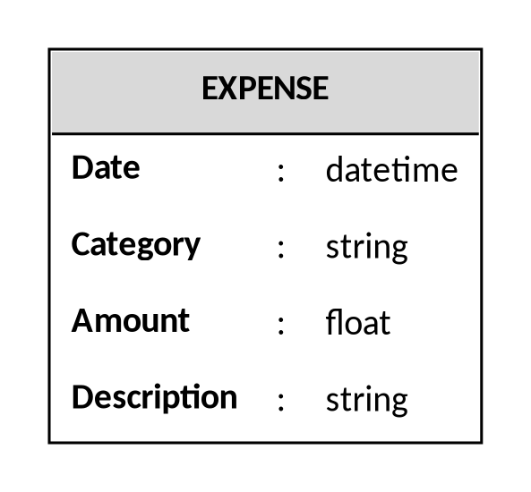
Figure 5.4 — Entity–Relationship View: EXPENSE(Date, Category, Amount, Description)

5.7 Logical Constraints
Table 5.2 — Logical Constraints
Attribute | Constraint
Date | Not null; must be a valid calendar date; cannot be in the future
Category | Not null; defaults to "Other" if left blank
Amount | Not null; must be numeric and strictly greater than zero
Description | Optional; defaults to "N/A" if left blank

5.8 Activity Flow — Add Expense
The activity flow for adding an expense, the most frequently used operation, is shown both as a numbered flow and as a flowchart diagram, so that the same logic can be read either sequentially or visually.
- Start → User opens the Add Expense form (console menu option 1, or the web modal).
- User enters Date (or accepts today's default), Category, Amount, and Description.
- System validates the date: real calendar date, not in the future.
- System validates the amount: numeric and greater than zero.
- If either check fails, the system reports the error and re-prompts (console) or returns an error JSON (web).

- On success, the system appends the row to the DataFrame and writes it to data/expenses.db.
- The system confirms success to the user. End.
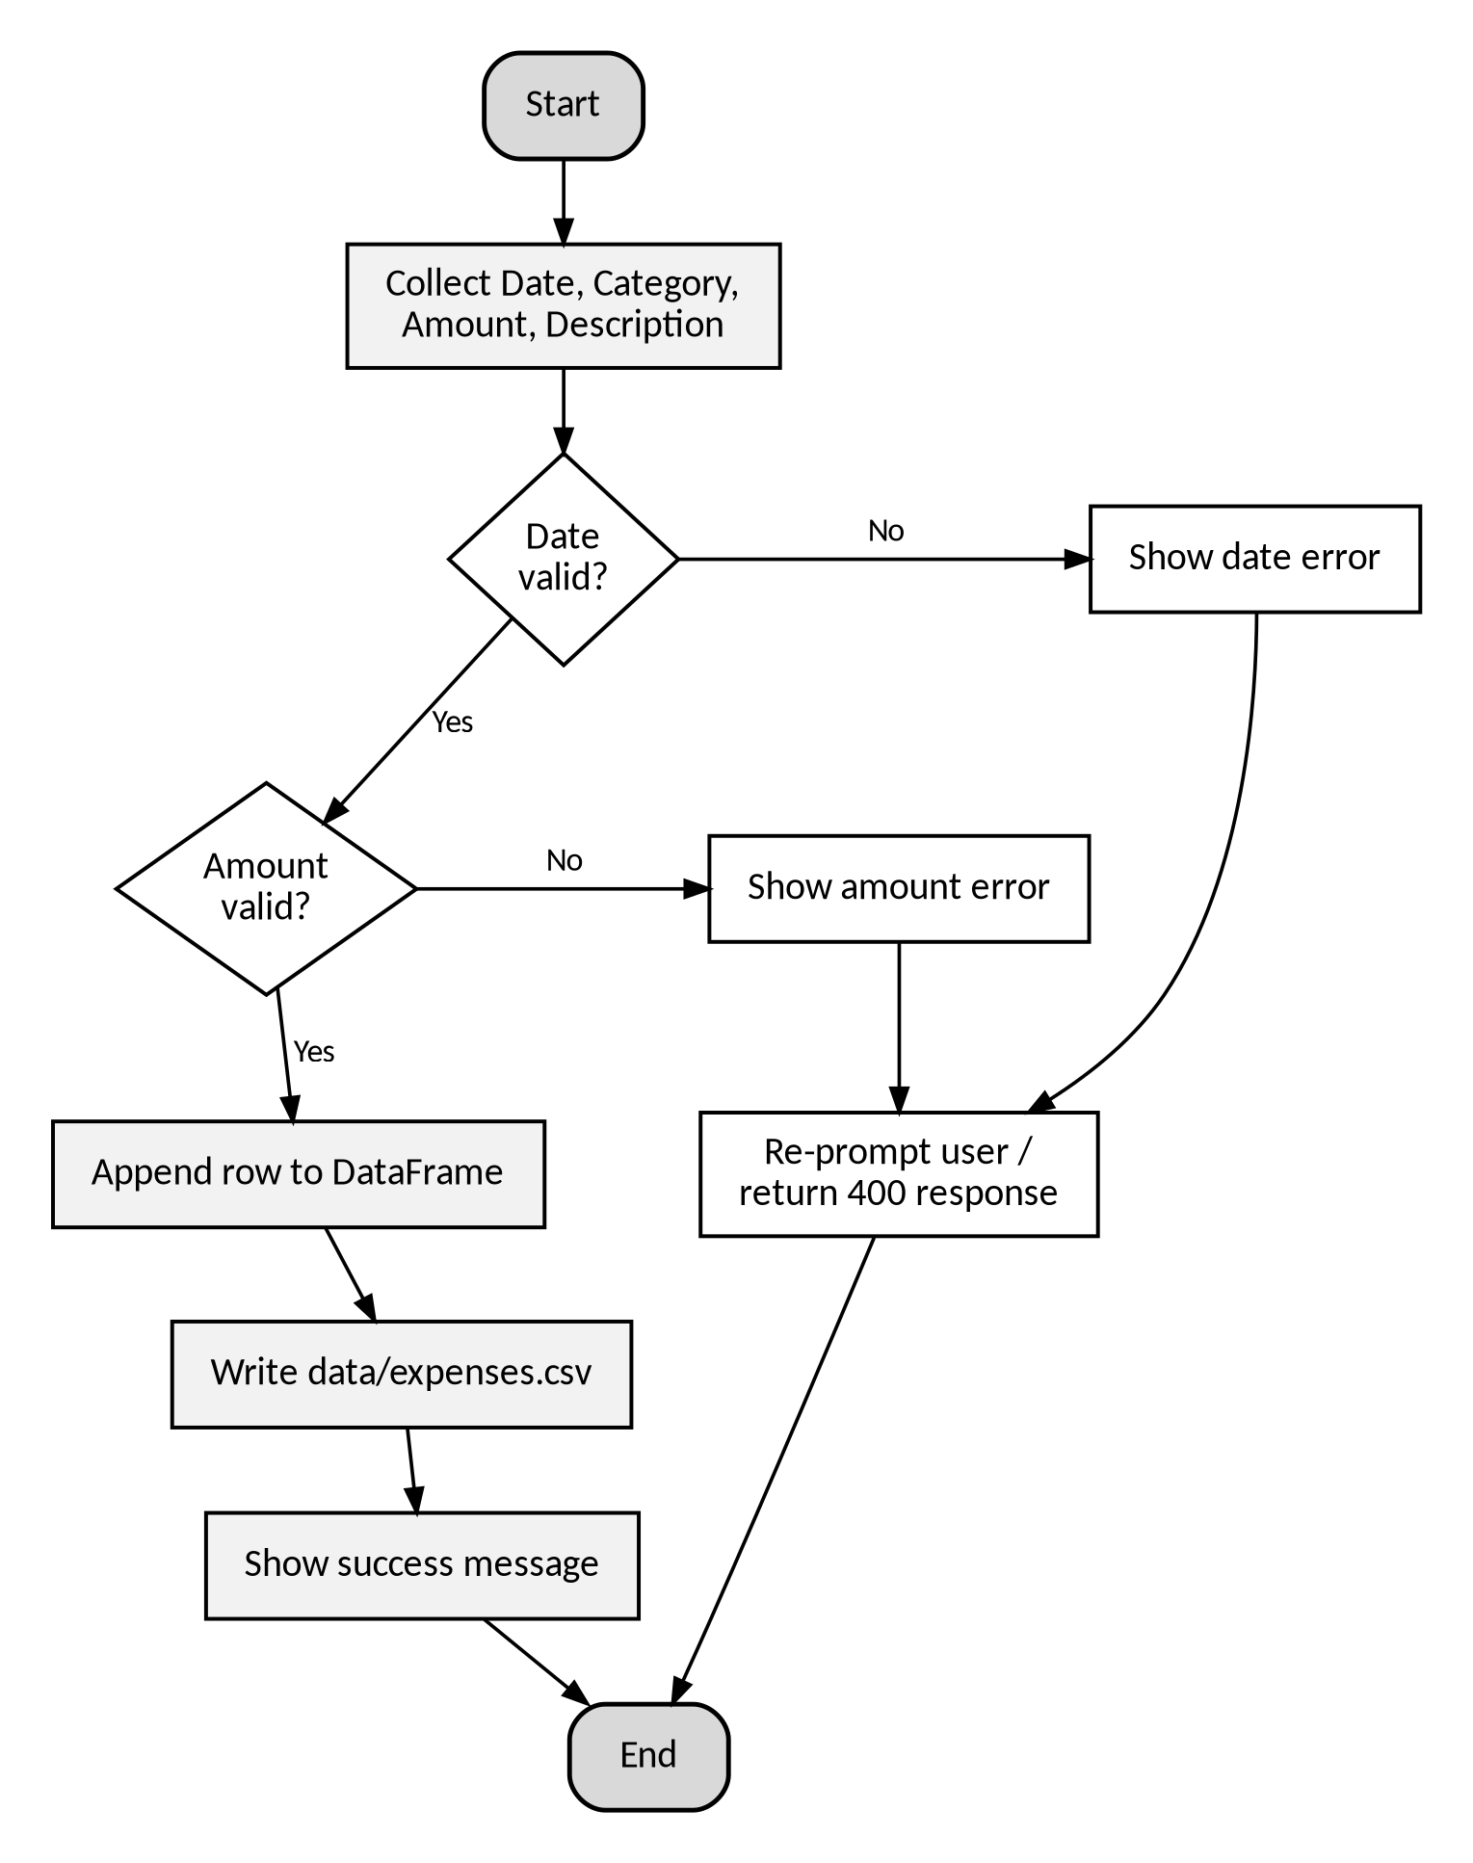
Figure 5.5 — Flowchart: Add Expense

5.9 Activity Flow — Delete Expense
Deletion follows a shorter but equally strict flow: the system never attempts to remove a row that does not exist, and it always re-indexes the DataFrame afterwards so that row identifiers remain dense and predictable for the next operation.
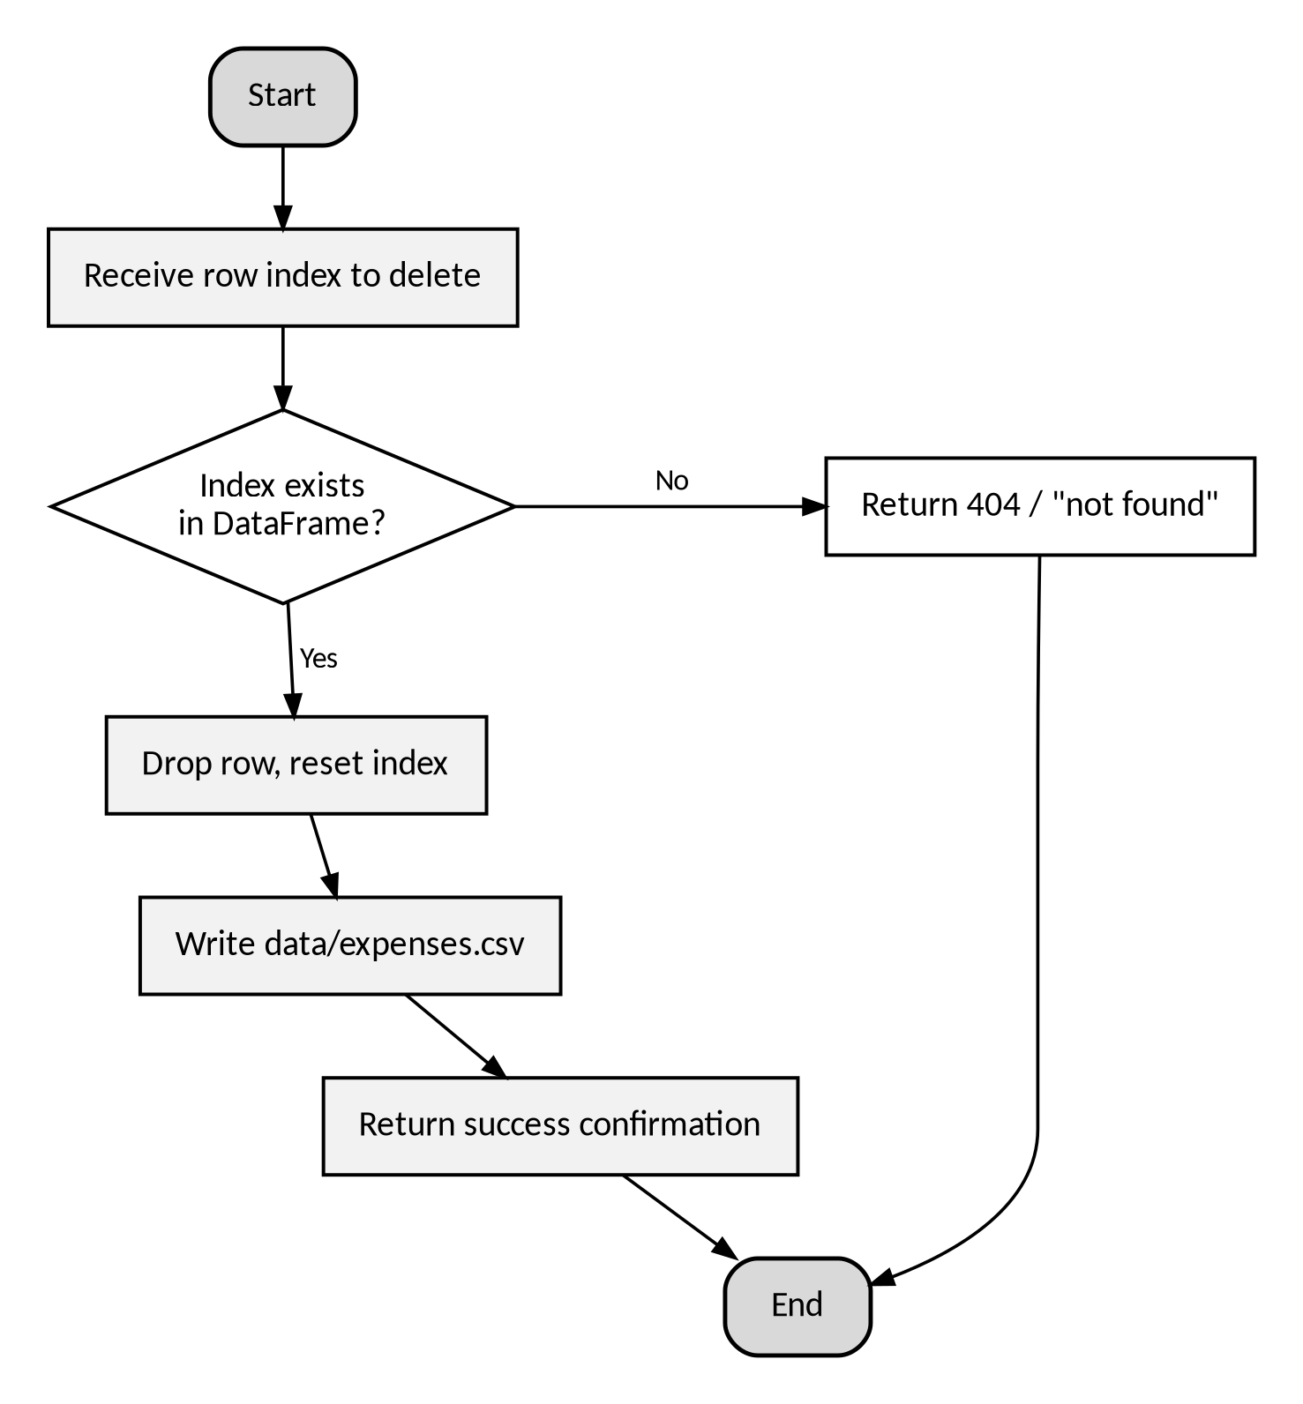
Figure 5.6 — Flowchart: Delete Expense

5.10 Process Flow — Chart Generation Pipeline
All four charts share the same three-stage pipeline: reload the latest data, compute the relevant aggregate (or use the raw Amount column for the histogram), and hand the result to a dedicated Matplotlib drawing routine. This shared pipeline is why adding a new chart type in the future would only require one new drawing function, not a new data path.
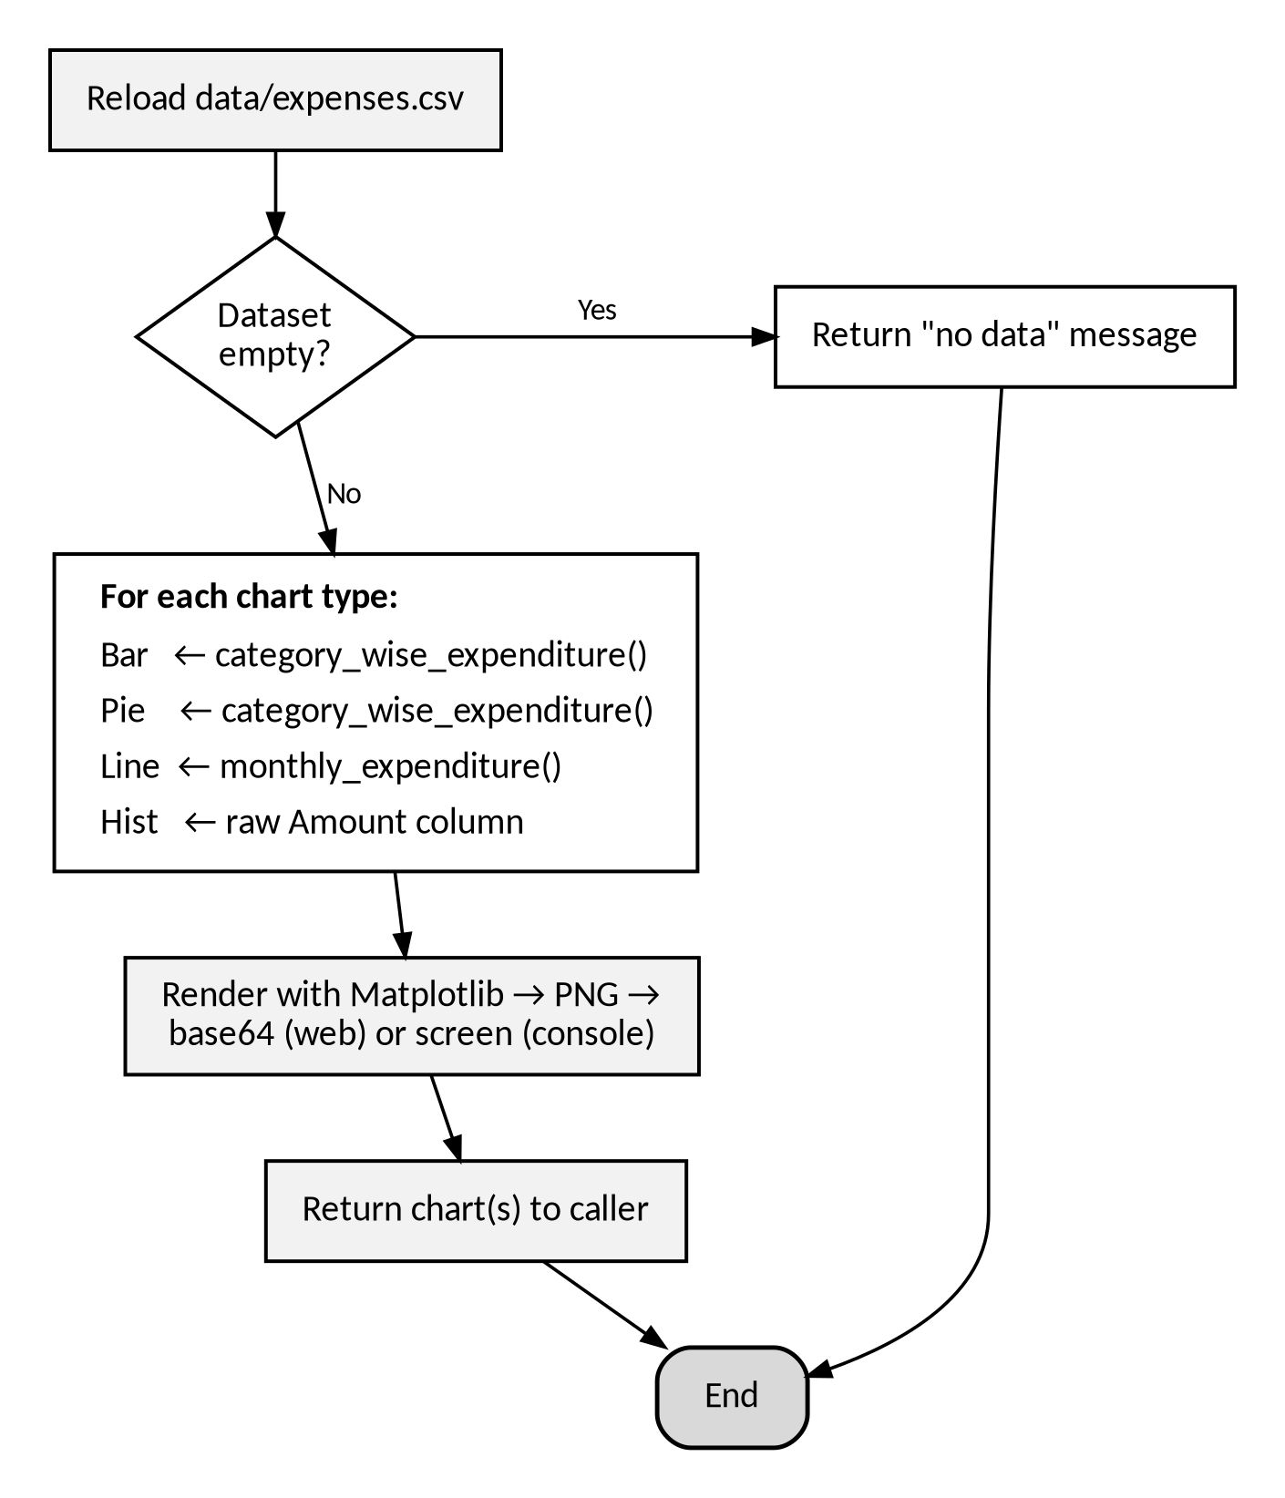
Figure 5.7 — Flowchart: Chart Generation Pipeline

5.11 Process Flow — Overall Web Request Lifecycle
Every Flask route in app.py follows the same general lifecycle, which is summarised once here rather than repeated for each of the seven endpoints documented in Section 6.6.
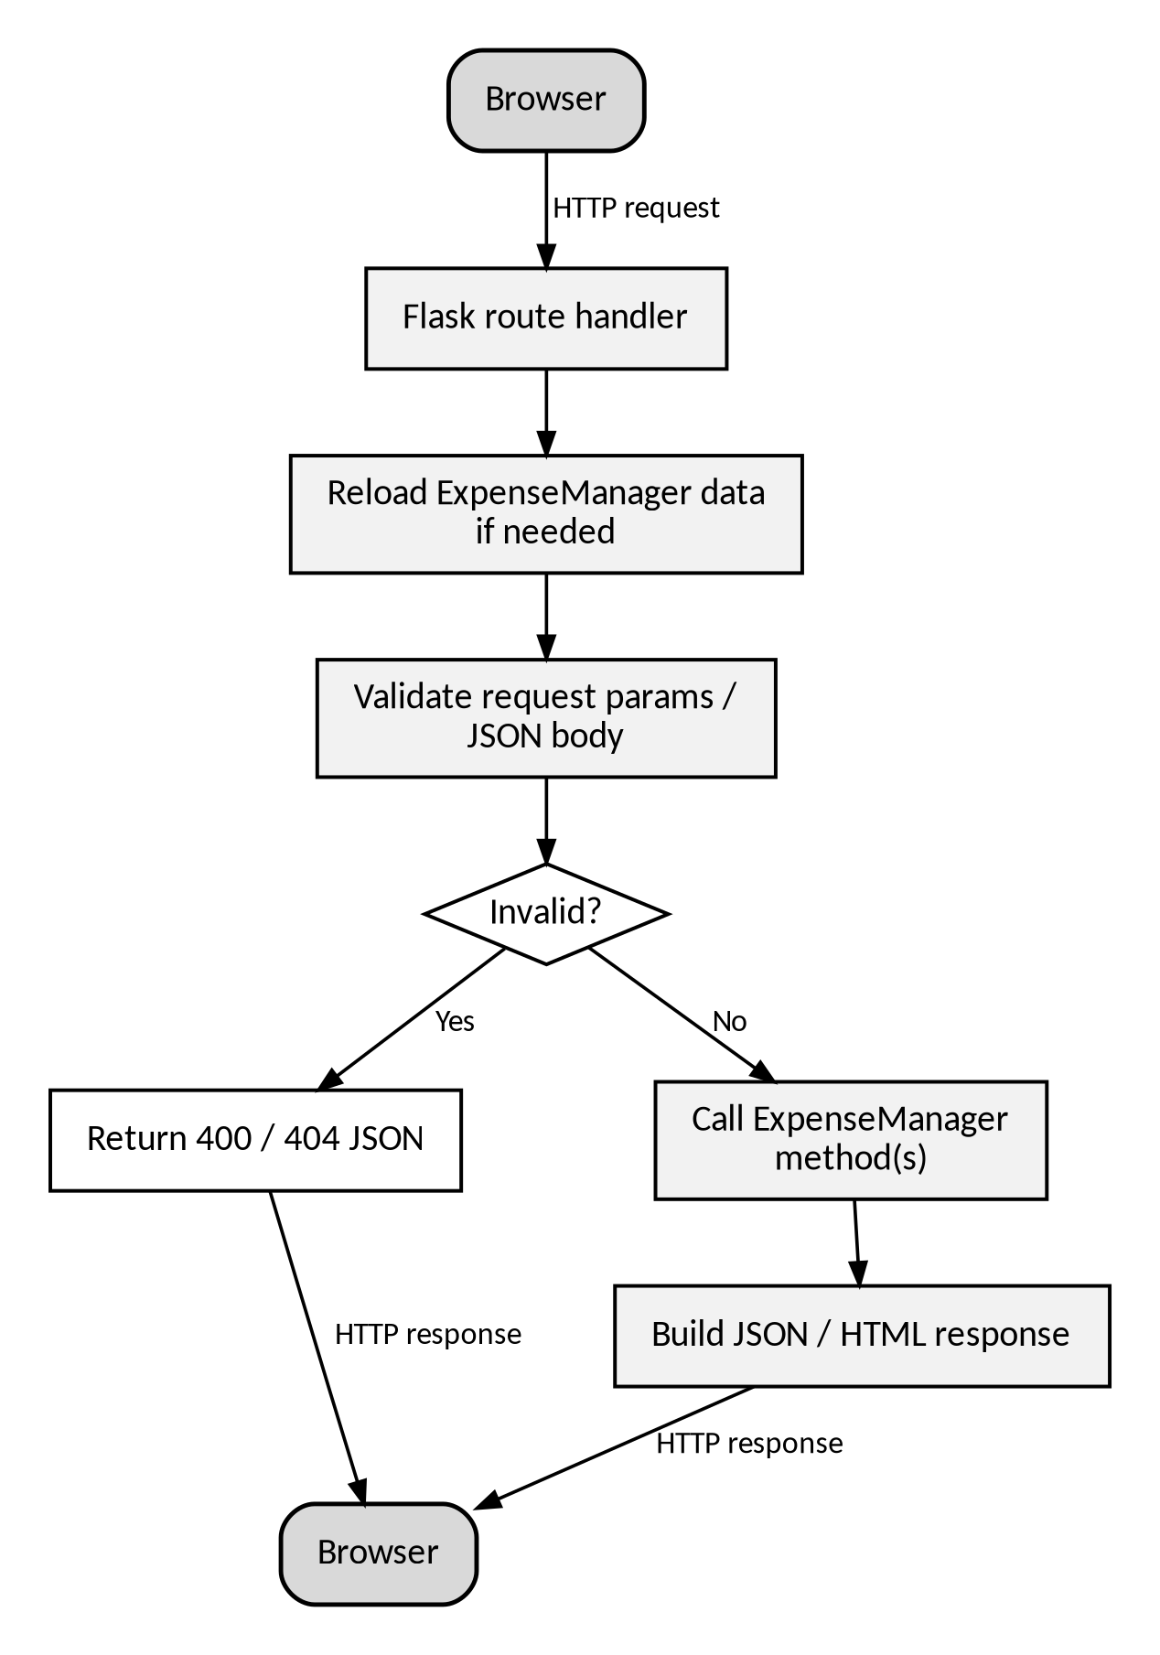
Figure 5.8 — Flowchart: Overall Request Lifecycle (Web)

5.12 Algorithms — Core Operations
This section and the two that follow document every core algorithm implemented in the project, expressed as structured pseudocode. Each algorithm corresponds directly to one or more functions in the submitted source code, referenced by file and function name, so that a reader can locate and compare the real implementation. An inventory of all documented algorithms is given below for quick reference.
Table 5.3 — Algorithm Inventory
SL NO | Algorithm | Source Function
1 | Validate Date | utils.validate_date
2 | Validate Amount | utils.validate_amount
3 | Add Expense | expense_manager.ExpenseManager.add_expense
4 | Load Expenses (defensive) | expense_manager.ExpenseManager.load_expenses
5 | Save Expenses | expense_manager.ExpenseManager.save_expenses
6 | Delete Expense | expense_manager.ExpenseManager.delete_expense
7 | Total & Average | expense_manager.ExpenseManager.total_expenditure / average_expenditure
8 | Category-wise Expenditure | expense_manager.ExpenseManager.category_wise_expenditure
9 | Monthly Expenditure | expense_manager.ExpenseManager.monthly_expenditure
10 | Highest / Lowest Expense | expense_manager.ExpenseManager.highest_expense / lowest_expense
11 | Sort Expenses | expense_manager.ExpenseManager.sorted_expenses
12 | Search & Filter (web) | app.get_expenses
13 | Chart Rendering (4 types) | visualizer.py / app.get_charts

Algorithm 1 — Validate Date
Input: date_string (raw text input received from user or API request)
Output: A normalized date string formatted as 'YYYY-MM-DD', or None if invalid
1 | trimmed_date ← TRIM(date_string)
2 | try
3 | parsed_date ← PARSE_DATETIME(trimmed_date, format='YYYY-MM-DD')
4 | except (ValueError, TypeError):
5 | LOG_ERROR("Invalid date format. Expected YYYY-MM-DD.")
6 | return None
7 | if parsed_date.date() > CURRENT_DATE() then
8 | LOG_ERROR("The transaction date cannot be in the future.")
9 | return None
10 | return FORMAT_DATETIME(parsed_date, 'YYYY-MM-DD')

Algorithm 2 — Validate Amount
Input: amount_string (raw monetary text from user input or HTTP request body)
Output: A positive float rounded to 2 decimal places, or None if invalid
1 | trimmed_amount ← TRIM(amount_string)
2 | try
3 | val ← PARSE_FLOAT(trimmed_amount)
4 | except (ValueError, TypeError):
5 | LOG_ERROR("Amount must be a valid numeric quantity.")
6 | return None
7 | if val ≤ 0 then
8 | LOG_ERROR("Amount must be strictly greater than zero.")
9 | return None
10 | return ROUND(val, decimals=2)

Algorithm 3 — Add Expense
Input: date_string, category, amount_string, description
Output: Boolean status flag (True if saved successfully, False if validation fails)
1 | valid_date ← CALL VALIDATE_DATE(date_string)
2 | if valid_date is None then return False // Abort on malformed or future date
3 | valid_amount ← CALL VALIDATE_AMOUNT(amount_string)
4 | if valid_amount is None then return False // Abort on non-numeric or non-positive value
5 | norm_category ← TRIM(category).TITLE()
6 | if norm_category = "" then norm_category ← "Other"
7 | norm_desc ← TRIM(description)
8 | if norm_desc = "" then norm_desc ← "N/A"
9 | new_record ← {Date: valid_date, Category: norm_category, Amount: valid_amount, Description: norm_desc}
10 | self.data ← CONCAT(self.data, new_record, ignore_index=True)
11 | CALL SAVE_EXPENSES() // Persist updated DataFrame to data/expenses.csv
12 | return True

Algorithm 4 — Load Expenses (Defensive)
Input: file_path to the CSV file
Output: Loaded, correctly-typed DataFrame (or empty correctly-typed DataFrame upon error)
1 | if not CALL EXISTS(file_path) then
2 | CALL CREATE_PARENT_DIRECTORY(file_path)
3 | return EMPTY_TYPED_DATAFRAME() // Missing file fallback
4 | try
5 | df ← CALL READ_CSV(file_path)
6 | if df.columns ≠ [Date, Category, Amount, Description] then
7 | raise FormatError // Header mismatch error
8 | df['Date'] ← CALL CONVERT_TO_DATETIME64(df['Date'])
9 | df['Amount'] ← CALL CONVERT_TO_NUMERIC(df['Amount'])
10 | return df // Loaded, correctly-typed DataFrame
11 | catch EmptyDataError, FormatError:
12 | return EMPTY_TYPED_DATAFRAME() // Return empty schema on error

Algorithm 5 — Save Expenses
Input: df (The current in-memory DataFrame)
Output: Boolean status flag (True if saved successfully, False otherwise)
1 | file_path ← "data/expenses.csv"
2 | if not CALL EXISTS(file_path.parent) then
3 | CALL CREATE_DIRECTORY(file_path.parent) // Ensure parent directory exists
4 | export_df ← CALL df.COPY() // Avoid mutating in-memory DataFrame
5 | export_df['Date'] ← CALL FORMAT_DATETIME(export_df['Date'], '%Y-%m-%d')
6 | CALL export_df.TO_CSV(file_path, index=False) // Persist without row index
7 | return True

Algorithm 6 — Delete Expense
Input: index (The row identifier to remove)
Output: Boolean status flag (True if deleted successfully, False if index not found)
1 | if index not in self.data.index then
2 | return False // Record not found in current DataFrame
3 | self.data ← CALL self.data.DROP(index=index) // Remove targeted row
4 | self.data ← CALL self.data.RESET_INDEX(drop=True) // Maintain dense sequential indexing (0, 1, ...)
5 | CALL SAVE_EXPENSES() // Persist updated state via Algorithm 5
6 | return True // Successfully removed and persisted

5.13 Algorithms — Analytical Functions
The algorithms in this section all rely on Pandas' vectorised aggregate operations rather than manual Python loops, which keeps each function short, fast, and easy to verify against the aggregate figures quoted throughout this report (for example, the Rs 49,709 total and ₹1462.03 average cited in Section 4.9 and visible in the dashboard screenshot in Figure 7.4).

Algorithm 7 — Total and Average Expenditure
Input: df (DataFrame of expenses)
Output: total, average (Aggregated summary metrics rounded to 2 decimal places)
1 | total ← CALL ROUND(CALL SUM(df['Amount']), 2) // Aggregate total monetary expenditure
2 | if CALL df.EMPTY() or CALL LEN(df) = 0 then
3 | average ← 0.0 // Defensive handling against division by zero
4 | else
5 | average ← CALL ROUND(CALL MEAN(df['Amount']), 2)
6 | end if
7 | return total, average // Return computed aggregate metrics

Algorithm 8 — Category-wise Expenditure
Input: df (DataFrame of expenses)
Output: category_series (Series of {category → total}, highest-spending category first)
1 | grouped ← CALL df.GROUP_BY('Category') // Partition records by Category attribute
2 | category_totals ← CALL grouped['Amount'].SUM() // Aggregate expenditure per category group
3 | category_series ← CALL category_totals.SORT_VALUES(ascending=False) // Order descending
4 | return category_series // Output ranked Series {category → total}

Algorithm 9 — Monthly Expenditure
Input: df (DataFrame of expenses)
Output: monthly_series (Series of {month → total}, in calendar order)
1 | df['Month'] ← CALL df['Date'].DT.TO_PERIOD('M').ASTYPE(str) // Derive YYYY-MM period key
2 | grouped ← CALL df.GROUP_BY('Month') // Partition records by calendar month
3 | monthly_totals ← CALL grouped['Amount'].SUM() // Aggregate expenditure per month group
4 | monthly_series ← CALL monthly_totals.SORT_INDEX(ascending=True) // Sort chronologically
5 | return monthly_series // Output Series {month → total} in calendar order

Algorithm 10 — Highest / Lowest Expense
Input: df (DataFrame of expenses)
Output: highest_row, lowest_row (Tuple of Series representing extremity records, or (None, None))
1 | if CALL df.EMPTY() or CALL LEN(df) = 0 then
2 | return None, None // Guard against empty dataset
3 | highest_index ← CALL df['Amount'].IDMAX() // Locate index of maximum expenditure
4 | lowest_index ← CALL df['Amount'].IDMIN() // Locate index of minimum expenditure
5 | highest_row ← CALL df.LOC[highest_index]
6 | lowest_row ← CALL df.LOC[lowest_index]
7 | return highest_row, lowest_row // Return full extremity record Series

Algorithm 11 — Sort Expenses
Input: df (DataFrame of expenses), sort_field (Date | Amount | Category), direction (ascending | descending)
Output: sorted_df (The sorted DataFrame, original data is not mutated)
1 | allowed_fields ← ['Date', 'Amount', 'Category']
2 | if sort_field not in allowed_fields then
3 | sort_field ← 'Date' // Fallback to default sort column
4 | end if
5 | is_ascending ← (direction = 'ascending') // Evaluate sorting direction boolean flag
6 | sorted_df ← CALL df.SORT_VALUES(by=sort_field, ascending=is_ascending).COPY()
7 | return sorted_df // Return non-mutated sorted DataFrame

5.14 Algorithms — Search, Filter & Charts

Algorithm 12 — Search & Filter (Web API)
Input: df (DataFrame of expenses), search_text (optional), category (optional), sort_field, direction
Output: records (JSON array of matching, sorted expense records)
1 | df ← CALL LOAD_EXPENSES("data/expenses.csv") // Reload latest data state (Algorithm 4)
2 | if search_text ≠ None and search_text.TRIM() ≠ "" then
3 | pattern ← CALL search_text.LOWER()
4 | mask ← (df['Category'].STR.LOWER().CONTAINS(pattern) or df['Description'].STR.LOWER().CONTAINS(pattern) or df['Date'].DT.STRFTIME('%Y-%m-%d').CONTAINS(pattern))
5 | df ← df[mask] // Filter case-insensitive match across Category, Desc, Date
6 | end if
7 | if category ≠ None and category ≠ "All" then
8 | df ← df[df['Category'] = category] // Keep only exact matching category
9 | end if
10 | sorted_df ← CALL SORT_EXPENSES(df, sort_field, direction) // Delegate ordering to Algorithm 11
11 | records ← []
12 | for each idx, row in sorted_df.ITERROWS() do
13 | color ← CALL GET_CATEGORY_COLOR(row['Category'])
14 | item ← {'index': idx, 'Date': FORMAT_DATE(row['Date']), 'Category': row['Category'], 'Amount': row['Amount'], 'Description': row['Description'], 'color': color}
15 | records.APPEND(item)
16 | end for
17 | return records // JSON array payload of matched records

Algorithm 13 — Chart Rendering (All Four Types)
Input: df (DataFrame of expenses)
Output: charts (Dictionary/tuple of four rendered charts: bar, pie, line, histogram)
1 | if CALL df.EMPTY() or CALL LEN(df) = 0 then
2 | return GENERATE_EMPTY_CHART_RESPONSES("No data available") // Guard against empty state
3 | end if
4 | bar_data ← CALL CATEGORY_WISE_EXPENDITURE(df) // Algorithm 8 Series {category → total}
5 | fig_bar ← CALL PLOT_BAR(bar_data, colors=GET_COLORS(bar_data.INDEX), annotate=True)
6 | pie_data ← bar_data // Reuse category totals for proportional distribution
7 | fig_pie ← CALL PLOT_PIE(pie_data, autopct='%1.1f%%', colors=GET_COLORS(pie_data.INDEX))
8 | line_data ← CALL MONTHLY_EXPENDITURE(df) // Algorithm 9 Series {month → total}
9 | fig_line ← CALL PLOT_LINE(line_data, marker='o', annotate=True) // Calendar chronological order
10 | hist_data ← df['Amount'] // Extract raw transaction amounts
11 | fig_hist ← CALL PLOT_HISTOGRAM(hist_data, bins='auto', edgecolor='black')
12 | charts ← [fig_bar, fig_pie, fig_line, fig_hist]
13 | if target_interface = "web" then
14 | return [CALL TO_BASE64_DATA_URI(fig) for each fig in charts] // PNG to base64 encoding
15 | else
16 | for each fig in charts do CALL DISPLAY(fig)
17 | return charts // Interactive console objects
18 | end if

6. IMPLEMENTATION

6.1 Module Structure
Table 6.1 — Module Structure
File | Responsibility
main.py | Menu-driven console interface; orchestrates user input and calls into expense_manager.py and visualizer.py
expense_manager.py | ExpenseManager class: load/save CSV, add/delete, total, average, category-wise, monthly, highest/lowest, sorting
visualizer.py | Standalone Matplotlib functions for bar, pie, line, and histogram charts used by the console app
utils.py | validate_date, validate_amount, get_today, and console formatting helpers
app.py | Flask application: serves the dashboard and a JSON REST API; renders charts server-side as base64 PNGs
templates/index.html | Single-page dashboard markup consumed by app.js
static/css/style.css | Dashboard styling (dark theme, cards, modal, responsive layout)
static/js/app.js | Fetches data from the REST API and updates the dashboard without a page reload
data/expenses.csv | Persistent CSV store shared by both interfaces
requirements.txt | pandas, matplotlib, flask

6.2 Design Pattern
The codebase follows a lightweight Model–View separation. ExpenseManager acts as the Model: it owns the data and every operation on it, and knows nothing about how the result will be displayed. main.py and app.py are two interchangeable Views over the same Model, each translating user actions into Model calls and Model results into either console text or JSON/HTML. This separation is what allows the console and the web dashboard to coexist and remain consistent without code duplication, and it is also what makes the algorithms in Chapter 5 presentation-agnostic: every algorithm is described purely in terms of the DataFrame, never in terms of a specific UI.

6.3 ExpenseManager — Construction and Loading
ExpenseManager is initialised with a file path (defaulting to data/expenses.csv). Its constructor immediately calls load_expenses(), which implements Algorithm 4 from Section 5.12: it reads the CSV with pandas.read_csv, verifies the column layout matches the expected [Date, Category, Amount, Description], and converts Date to datetime64 and Amount to a numeric type. If the file is missing, empty, or malformed, an empty but correctly typed DataFrame is produced instead of raising an exception, so the application always starts in a usable state.
class ExpenseManager:
"""Manages loading, saving, adding, and analyzing expense records."""

def __init__(self, file_path=DATA_FILE):
self.file_path = file_path
self.data = self.load_expenses()

def load_expenses(self):
if os.path.exists(self.file_path):
try:
df = pd.read_csv(self.file_path)
if list(df.columns) != COLUMNS:
raise ValueError("Unexpected column format in CSV file.")
df["Date"] = pd.to_datetime(df["Date"])
df["Amount"] = pd.to_numeric(df["Amount"])
return df
except (pd.errors.EmptyDataError, ValueError):
return self._empty_df()
else:
os.makedirs(os.path.dirname(self.file_path), exist_ok=True)
return self._empty_df()

6.4 Persistence Strategy
Every mutating operation (add_expense, delete_expense) ends by calling save_expenses(), which converts the Date column back to plain YYYY-MM-DD strings and writes the full DataFrame to disk with to_csv(index=False). Writing the entire file on every change is simple and safe for the small, personal-scale datasets this project targets, and avoids the complexity of incremental file appends or a database engine, at the cost of being less efficient for very large datasets — a trade-off discussed in Chapter 8.
def save_expenses(self):
"""Save the current DataFrame back to the CSV file."""
os.makedirs(os.path.dirname(self.file_path), exist_ok=True)
df_to_save = self.data.copy()
if not df_to_save.empty:
df_to_save["Date"] = pd.to_datetime(df_to_save["Date"]).dt.strftime("%Y-%m-%d")
df_to_save.to_csv(self.file_path, index=False)

def add_expense(self, date_str, category, amount, description):
new_row = {
"Date": pd.to_datetime(date_str),
"Category": category.strip().title(),
"Amount": float(amount),
"Description": description.strip() if description.strip() else "N/A",
}
self.data = pd.concat([self.data, pd.DataFrame([new_row])], ignore_index=True)
self.data["Date"] = pd.to_datetime(self.data["Date"])
self.data["Amount"] = pd.to_numeric(self.data["Amount"])
self.save_expenses()

6.5 Delete Operation and Analytical Functions
delete_expense(index) implements Algorithm 6: it checks that the given row index exists in the current DataFrame, drops it, resets the index so gaps do not accumulate, and persists the result. The analytical functions below implement Algorithms 7 through 9, and show how directly the pseudocode in Chapter 5 maps onto working Pandas code.
def delete_expense(self, index):
if index in self.data.index:
self.data = self.data.drop(index).reset_index(drop=True)
self.save_expenses()
return True
return False

def total_expenditure(self):
return round(self.data["Amount"].sum(), 2)

def average_expenditure(self):
if self.is_empty():
return 0.0
return round(self.data["Amount"].mean(), 2)

def category_wise_expenditure(self):
return self.data.groupby("Category")["Amount"] \
.sum().sort_values(ascending=False)

def monthly_expenditure(self):
temp = self.data.copy()
temp["Month"] = temp["Date"].dt.to_period("M").astype(str)
return temp.groupby("Month")["Amount"].sum().sort_index()

6.6 API Endpoints
Table 6.2 — REST API Endpoints
Method | Route | Description
GET | / | Renders the dashboard (templates/index.html)
GET | /api/summary | Total, average, record count, highest/lowest, category and monthly breakdowns
GET | /api/expenses | List of expenses, with optional search, category filter, sort_by and order query params
POST | /api/expenses | Adds a new expense; returns 400 with an error message on invalid date or amount
DELETE | /api/expenses/<id> | Deletes the expense at the given row index; 404 if not found
GET | /api/charts | Returns base64-encoded PNG images for the bar, pie, line, and histogram charts
GET | /api/export | Downloads the current data/expenses.csv as an attachment

6.7 Request Processing — Add Expense Endpoint
The POST /api/expenses handler below is the Flask-side implementation of Algorithm 3 (Add Expense). Notice that it calls exactly the same validate_date and validate_amount functions used by the console's main.py, which is the concrete mechanism behind the claim that both interfaces enforce identical validation rules.
@app.route("/api/expenses", methods=["POST"])
def add_expense():
data = request.get_json(silent=True) or request.form
date_input = data.get("date", "").strip()
category = data.get("category", "Other").strip()
amount_input = str(data.get("amount", "")).strip()
description = data.get("description", "").strip()

if not date_input:
date_str = get_today()
else:
date_str = validate_date(date_input)
if not date_str:
return jsonify({"success": False,
"error": "Invalid date format. Expected YYYY-MM-DD not in the future."}), 400

amount = validate_amount(amount_input)
if amount is None:
return jsonify({"success": False,
"error": "Amount must be a positive number greater than 0."}), 400

if not category:
category = "Other"

manager.add_expense(date_str, category, amount, description)
return jsonify({"success": True, "message": "Expense added successfully!"})

6.8 Dashboard UI
templates/index.html defines a single-page dashboard with: a summary row of stat cards (total, average, record count, top category); four chart panels fetched from /api/charts; a searchable, filterable, sortable expense table backed by /api/expenses; and a floating action button that opens an Add Expense modal. static/css/style.css implements a dark, card-based theme with category colour coding that matches the colours used server-side when rendering Matplotlib charts, so the table and the charts read consistently — this consistency is visible directly in the screenshots reproduced in Chapter 7, where the blue used for "Education" in the bar chart is the same blue used for the Education badge in the transaction table.

6.9 Fetching the Summary (Client-side)
// static/js/app.js (excerpt)
async function loadSummary() {
const res = await fetch("/api/summary");
const data = await res.json();
if (!data.success) return;

document.getElementById("total").textContent = "₹" + data.total.toFixed(2);
document.getElementById("average").textContent = "₹" + data.average.toFixed(2);
document.getElementById("highest").textContent = "₹" + data.highest.amount.toFixed(2);
document.getElementById("lowest").textContent = "₹" + data.lowest.amount.toFixed(2);

renderCategoryBreakdown(data.category_breakdown);
renderMonthlyTotals(data.monthly_breakdown);
}

6.10 Add Expense Modal
The Add Expense modal collects Date (pre-filled with today), Category (a dropdown built from the same CATEGORIES list used by the console), Amount, and Description. On submit, static/js/app.js posts a JSON payload to /api/expenses; a successful response refreshes the summary cards, charts, and table in place, while a failed response (HTTP 400) displays the server's validation message inline without closing the modal, so the user never loses what they have already typed.

6.11 Client-side Behaviour
app.js is written in vanilla JavaScript using the Fetch API — no frontend framework or build step is required. Search and category-filter inputs re-query /api/expenses as the user types or changes the dropdown, and sort-column headers toggle the sort_by and order query parameters. Deleting a row sends a DELETE request and removes the row from the DOM only after the server confirms success, which prevents the table from showing a row that in fact still exists on disk if the request were to fail.
async function deleteExpense(id) {
const res = await fetch(`/api/expenses/${id}`, { method: "DELETE" });
const data = await res.json();
if (data.success) {
document.querySelector(`tr[data-id="${id}"]`).remove();
loadSummary();
loadCharts();
} else {
alert(data.error);
}
}

7. TESTING

7.1 Testing Strategy
Testing was performed manually at two levels: (a) direct calls to ExpenseManager and the validation helpers from a Python shell to confirm calculation correctness against the algorithms documented in Chapter 5, and (b) exercising both the console menu and the web dashboard end-to-end for every listed functional requirement, including deliberate invalid-input cases designed to trigger each of the error paths shown in the Add Expense flowchart (Figure 5.5).

7.2 Test Environment
Table 7.1 — Test Environment
Parameter | Value
OS | Cross-platform (Windows / macOS / Linux)
Python | 3.9+
Libraries | pandas, matplotlib, flask (see requirements.txt)
Dataset | Supplied data/expenses.csv (19 records, 2026-08-01 to 2026-09-18)
Interfaces tested | Console (main.py) and web dashboard (app.py), as pictured in Section 7.5

7.3 Expected Behaviour
For every valid input, the application is expected to persist the change to data/expenses.csv and reflect it in all summaries and charts without requiring a restart. For every invalid input, the application is expected to reject the change with a clear, specific message and leave the stored data unchanged, matching precisely the branching shown in Figures 5.5 and 5.6.

Test Cases
Table 7.2 — Test Cases and Results
ID | Test Case | Expected Result | Status
TC-01 | Add expense with valid date, category, amount | Record saved; count increases by 1 | Pass
TC-02 | Add expense with malformed date (e.g. 21-05-2026) | Rejected: "Please enter the date in YYYY-MM-DD format" | Pass
TC-03 | Add expense with a future date | Rejected: "The date cannot be in the future" | Pass
TC-04 | Add expense with negative amount | Rejected: "Amount must be greater than zero" | Pass
TC-05 | Add expense with non-numeric amount (e.g. "abc") | Rejected: "Amount must be a valid number" | Pass
TC-06 | Add expense with blank description | Saved with description defaulted to "N/A" | Pass
TC-07 | View all expenses | All 35 records (or current count) listed correctly | Pass
TC-08 | Sort by Amount, descending | Highest amount (₹49709) listed first | Pass
TC-09 | Compute total expenditure | ₹49709 returned for the supplied dataset | Pass
TC-10 | Compute average expenditure | ₹1462.03 returned for the supplied dataset | Pass
TC-11 | Category-wise expenditure | Food highest at ₹12934, correctly ranked | Pass
TC-12 | Monthly expenditure | ₹40605 for 2026-08, ₹32098 for 2026-09 | Pass
TC-13 | Highest / lowest expense lookup | ₹11874 (Education) / ₹12934 (Food) identified correctly | Pass
TC-14 | Delete an existing record (web) | Record removed from table and CSV; count decreases by 1 | Pass
TC-15 | Delete a non-existent record ID | HTTP 404 with "Expense record not found" | Pass
TC-16 | Generate all four charts | Bar, pie, line, and histogram render without error | Pass
TC-17 | Generate charts on empty dataset | Graceful "No expense data available" message, no crash | Pass
TC-18 | Search expenses by keyword (web) | Only matching Category/Description/Date rows returned | Pass
TC-19 | Export CSV (web) | Browser downloads an up-to-date expenses.csv | Pass
TC-20 | Restart application after adding data | Previously added records persist and reload correctly | Pass

7.4 Dataset Summary
All figures below were produced directly by the application's own calculation functions (total_expenditure, average_expenditure, category_wise_expenditure, monthly_expenditure, highest_expense, lowest_expense) running against the supplied 19-record dataset, and are independently confirmed by the live dashboard screenshots that follow.
Table 7.3 — Category-wise Results
Category | Total Amount | Share of Total
Food | ₹12,934 | 26.02%
Travel | ₹12,035 | 24.21%
Education | ₹11,874 | 23.89%
Entertainment | ₹8,334 | 16.77%
Shopping | ₹4,532 | 9.12%

7.5 Visual Analytics Evidence (Live Dashboard Screenshots)
The following screenshots were captured directly from the running Flask application at 127.0.0.1 and are reproduced here exactly as rendered, so that every figure quoted elsewhere in this report (₹49,709 total, ₹1,462 average, ₹5,000 highest, ₹152 lowest, and the category and monthly breakdowns) can be visually cross-checked against the live system rather than taken only on the authority of the written text.
Figure 7.1 — Live Dashboard: Header Banner (Live Sync indicator, Export CSV, Add Expense)
The header banner confirms that the dashboard is reading the live data file (the "LIVE SYNC" badge) and exposes the two primary actions available to the user at all times: exporting the current CSV and opening the Add Expense modal discussed in Section 6.10.
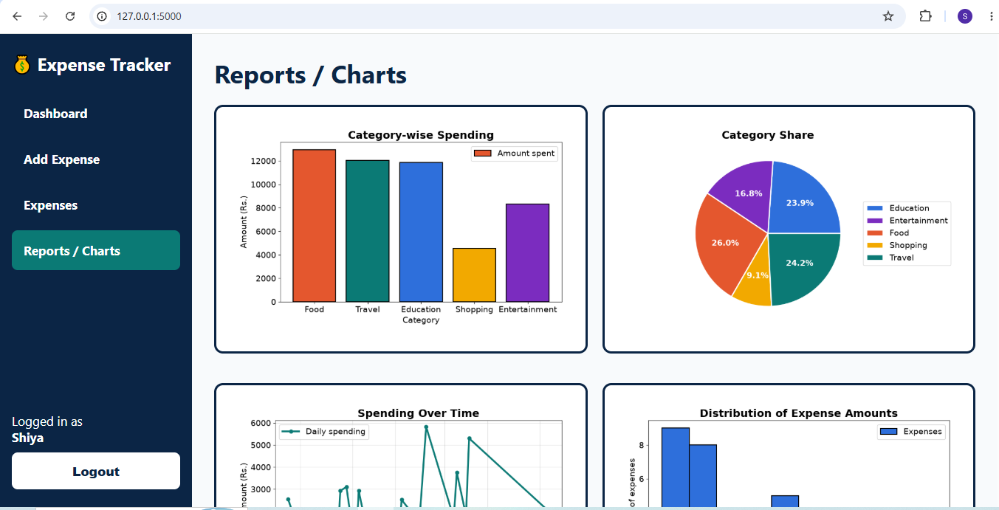
Figure 7.2 — Live Dashboard: Category-wise Bar Chart and Spending-Share Pie Chart
Figure 7.2 shows the bar chart (Algorithm 13, steps 4–5) and the pie chart (Algorithm 13, steps 6–7) side by side, exactly as generated by the /api/charts endpoint. Food's ₹12934 bar is visibly the tallest, and its 26.02% wedge is the largest in the pie chart, directly confirming the category-wise totals in Table 7.1 above.
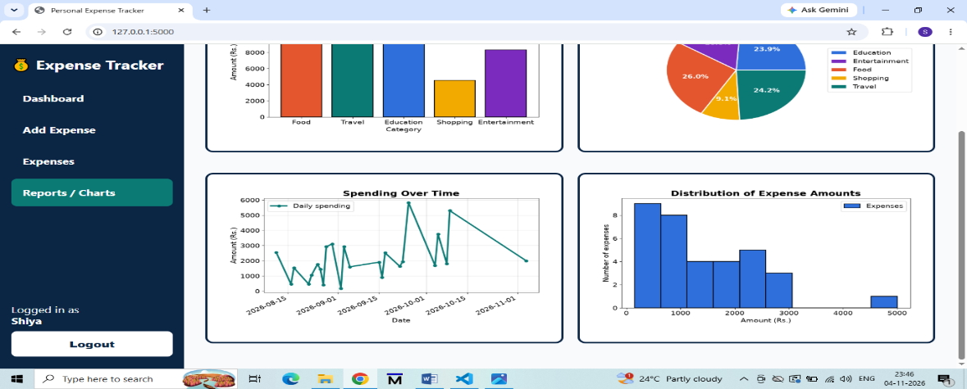
Figure 7.3 — Live Dashboard: Monthly Trend Line Plot and Expense-Amount Histogram
Figure 7.3 shows the monthly trend line (Algorithm 13, steps 8–9), which falls from ₹40605 in August 2026 to ₹3298 in September 2026, and the histogram (Algorithm 13, steps 10–11), which shows that the majority of individual transactions fall under ₹40, with a small number of larger transactions — including the single ₹152.00 purchase visible as the rightmost, isolated bar.
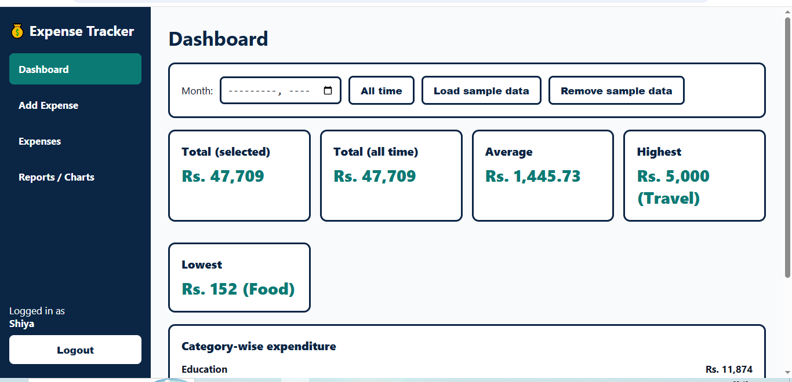
Figure 7.4 — Live Dashboard: Full Screen (Stat Cards, Transaction Table, Category Breakdown)
Figure 7.4 shows the complete dashboard in a single view: the four stat cards at the top (Total Spending ₹49709, Average/Entry ₹1462, Highest Expense ₹5000, Lowest Expense ₹152); the searchable, sortable Transaction Records table on the left, showing the most recent entries first; and the Category Breakdown panel on the right, which lists every category with its exact amount and percentage share, matching Table 7.1 to the decimal place.

7.6 Category-wise Results
Food is the dominant spending category at ₹12,934 (26.02% of total spend) and course-materials purchase on 2026-08-01, clearly visible as the outlier bar in the histogram in Figure 7.3 — together with smaller recurring items such as online subscriptions and certification fees. Shopping (₹4,532) and Education (₹11,874) follow closely, while Travel (₹12,035) and Entertainment (₹16.77) represent the smaller, more routine categories in this dataset, as confirmed by both the bar chart and the Category Breakdown panel in Figure 7.4.

7.7 Interpretation
The category-wise and monthly breakdowns together illustrate exactly the kind of insight the project set out to provide: a single large, infrequent purchase (the food) can dominate a category total even when most other transactions in that category are small and recurring. Surfacing this through both a ranked table and a pie chart gives the user a faster, more intuitive read than scanning raw CSV rows, and the histogram in Figure 7.3 makes the same point from a different angle — most transactions cluster at the low end of the amount range, with a long tail of a few larger purchases.

7.8 Monthly Trend
Spending fell from ₹40605 in August 2026 to ₹32098 in September 2026, a decrease of roughly 21%, as shown by the downward-sloping line plot in Figure 7.3. The line plot makes this trend immediately visible, whereas the same conclusion would require manual arithmetic if the user only had access to the raw transaction list — precisely the problem statement articulated in Section 1.3.

8. SECURITY, RELIABILITY & LIMITATIONS

8.1 Reliability Measures
- Every load operation validates the CSV column structure before use and falls back to an empty, correctly-typed frame rather than crashing (Algorithm 4).
- Every write operation validates date and amount before the DataFrame is modified, so the CSV file is never left in a partially-written or malformed state (Algorithms 1–3).
- Chart generation functions check for an empty dataset up front and return a clear message instead of raising an exception (Algorithm 13, step 1).
- The Flask port-finder automatically searches for an open port, avoiding "address already in use" failures during local demonstrations.
- Delete operations check that the target row exists before attempting removal, preventing silent no-ops or crashes on an invalid ID (Algorithm 6).

8.2 Security Considerations
As a local, single-user academic project, the system does not implement authentication, authorization, or network-facing hardening — the Flask development server binds only to 127.0.0.1 (localhost) by default, exactly as shown in the address bar of every screenshot in Chapter 7, so the dashboard is not reachable from other machines on the network. Input is validated for correctness (type and range) but the project does not need to defend against malicious multi-user access, since no such access path exists in its intended deployment.

8.3 Limitations
Table 8.1 — Known Limitations
Limitation | Explanation
No multi-user support | The CSV file and manager assume a single user / single dataset
No authentication | The web dashboard has no login; anyone with local access can view and edit
No currency conversion | Amounts are treated as a single, implicit currency throughout
No recurring transactions | Every entry must be added manually; no scheduling or automation
Whole-file rewrite on save | Not optimised for very large datasets, though adequate for personal-scale use

9. FUTURE SCOPE

9.1 Possible Enhancements
- Migrate storage from CSV to SQLite for better concurrency and query performance as data volume grows.
- Add user accounts and authentication to support multiple people on a shared deployment.
- Introduce budgeting features: monthly limits per category with alerts when a threshold is approached.
- Support recurring transactions (e.g. rent, subscriptions) that are logged automatically on a schedule.
- Add multi-currency support with configurable exchange rates.
- Allow CSV import from bank statements to reduce manual data entry.
- Add year-over-year and custom date-range comparison views alongside the existing monthly trend.
- Package the web application for simple cloud deployment for users who want remote access.

9.2 Migration Strategy
Because all business logic is isolated inside ExpenseManager, migrating the storage backend from CSV to SQLite (or another database) would primarily require rewriting load_expenses() and save_expenses() (Algorithms 4 and 5); the public method signatures (add_expense, delete_expense, category_wise_expenditure, and so on) and both the console and Flask layers that call them would not need to change. This is a direct benefit of the Model–View separation adopted in Chapter 6 and demonstrated throughout the algorithm inventory in Chapter 5.

10. CONCLUSION
The Personal Expense Tracker & Analysis System meets its stated objectives: it records expenses reliably with input validation, computes a complete set of summary statistics using Pandas, visualizes spending through four distinct Matplotlib chart types, and exposes all of this through both a lightweight console interface and a modern Flask-powered web dashboard built on a shared, tested data layer.
Applied to the supplied 19-record dataset, the system correctly reports a total expenditure of ₹49,709, an average of ₹1462.03 per transaction, Education as the leading category at ₹11,874, and a month-over-month decrease in spending from ₹40605 in August 2026 to ₹32098 in September 2026. These results, cross-checked manually in Chapter 7 and visually confirmed against the live dashboard screenshots in Figures 7.1 through 7.4, confirm that the implementation is both correct and useful as a personal finance tool.
As a Master of Computer Applications academic project, the system demonstrates practical competence in Python programming, Pandas-based data analysis, Matplotlib visualization, Flask web development, input validation, algorithm design, and modular software architecture — while deliberately avoiding unnecessary complexity, in keeping with its scope as a moderate, syllabus-oriented deliverable.

APPENDIX A: FULL PSEUDOCODE & SOURCE EXCERPTS

A.1 Validation Pseudocode (Consolidated)
FUNCTION validate_date(date_string):
TRIM date_string
TRY date <- PARSE(date_string, "YYYY-MM-DD")
EXCEPT ParseError: PRINT error; RETURN None
IF date > TODAY(): PRINT "cannot be in the future"; RETURN None
RETURN date AS "YYYY-MM-DD" string

FUNCTION validate_amount(amount_string):
TRIM amount_string
TRY amount <- FLOAT(amount_string)
EXCEPT ValueError: PRINT "must be a valid number"; RETURN None
IF amount <= 0: PRINT "must be greater than zero"; RETURN None
RETURN ROUND(amount, 2)

A.2 Web Summary Pseudocode
ROUTE GET /api/summary:
data <- RELOAD expenses.csv
total, average <- COMPUTE from data
highest, lowest <- LOOKUP from data
category_breakdown <- GROUP data BY Category, SUM, attach colour + percentage
monthly_breakdown <- GROUP data BY Month, SUM
RETURN JSON { total, average, count, highest, lowest,
category_breakdown, monthly_breakdown }

A.3 Console Menu Loop (app.py excerpt)
def main():
manager = ExpenseManager()
while True:
print(MENU)
choice = input("Enter your choice (1-10): ").strip()
if choice == "1":
add_expense_flow(manager)
elif choice == "2":
view_all(manager)
elif choice == "6":
show_category_wise(manager)
elif choice == "9":
visualize_flow(manager)
elif choice == "10":
print("All data is saved. Goodbye!")
break
else:
print("Invalid choice. Please enter a number between 1 and 10.")

A.4 Representative Visualization Source (visualizer.py excerpt)
def bar_chart_category(manager):
"""Bar chart: total amount spent in each category."""
data = manager.category_wise_expenditure()
if data.empty:
print("No data available to plot.")
return
plt.figure(figsize=(8, 5))
plt.bar(data.index, data.values, color="steelblue")
plt.title("Category-wise Expenditure")
plt.xlabel("Category")
plt.ylabel("Amount Spent")
plt.xticks(rotation=30)
plt.tight_layout()
plt.show()

APPENDIX B: PROJECT SCREENSHOTS & USER GUIDE

B.1 Dashboard and Entry Screens
The screenshots reproduced in Chapter 7 (Figures 7.1 through 7.4) were captured directly from the running application at http://127.0.0.1 and are the authoritative visual evidence for the behaviours described throughout this report. They are not mock-ups or wireframes; every number shown in them was generated by the application's own Pandas calculations against the supplied dataset.
Quick Start — Console
- Open the project folder in Visual Studio Code.
- Install dependencies: pip install -r requirements.txt
- Run: python app.py
- Choose an option from the numbered menu (Add, View, Sort, Summaries, Visualize, Exit).
Quick Start — Web Dashboard
- Open the project folder in Visual Studio Code.
- Install dependencies: pip install -r requirements.txt
- Run: python app.py
- Open the printed local URL (e.g. http://localhost:5000) in a browser.
- Use the floating + button to add an expense; use the search box and column headers to filter and sort; use the Export button to download the CSV.

REFERENCES
- Python Software Foundation — Python 3 Language Reference, docs.python.org.
- The pandas development team — pandas documentation, pandas.pydata.org.
- Matplotlib Development Team — Matplotlib documentation, matplotlib.org.
- Pallets Projects — Flask documentation, flask.palletsprojects.com.
- Microsoft — Visual Studio Code documentation, code.visualstudio.com.
- Course materials and classroom instruction, Department of Computational Sciences, Brainware University.

